[**Assembly programming**, also known as **assembler language**, is a **low-level programming language** that directly communicates with computer hardware, using mnemonics to represent processor operations and translating them into machine code instructions specific to a particular architecture1](https://en.wikipedia.org/wiki/Assembly_language).

Here are **five free reference links** where you can learn assembly programming:

1. [**GeeksforGeeks**](https://www.geeksforgeeks.org/what-is-assembly-language/): GeeksforGeeks provides a concise explanation of assembly language, its role between high-level languages and binary code, and its human-readable format[2](https://www.geeksforgeeks.org/what-is-assembly-language/).
2. [**TutorialsPoint**](https://www.tutorialspoint.com/assembly_programming/index.htm): TutorialsPoint offers an assembly programming tutorial covering the basics from scratch. [It includes information on assemblers like NASM and MASM](https://en.wikipedia.org/wiki/Assembly_language)[3](https://www.tutorialspoint.com/assembly_programming/index.htm).





1. [**FreeCodeCamp**](https://www.classcentral.com/course/freecodecamp-assembly-language-programming-with-arm-full-tutorial-for-beginners-104842): FreeCodeCamp’s course focuses on ARM assembly language programming, suitable for beginners seeking a deeper understanding of computer programming and hardware interactions[4](https://www.classcentral.com/course/freecodecamp-assembly-language-programming-with-arm-full-tutorial-for-beginners-104842).

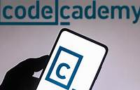

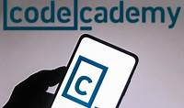

1. [**Codecademy**](https://www.codecademy.com/learn/computer-architecture-assembly-language): Codecademy’s “Computer Architecture: Assembly Language” course delves into the compilation process and writing your own assembly code, bridging the gap between high-level code and binary instructions[5](https://www.codecademy.com/learn/computer-architecture-assembly-language).

Happy learning! 🚀